Third Year Project Proposal
【Blockchain for Dog Welfare and Protection (tbd)】

Abstract
This project explores how blockchain technology can enhance dog welfare and protection by creating a secure transparent, and tamper-proof system to record key events in a dog’s life.
DRAFTS

- Why does this topic matter?
Dog abandonment and neglect remain major global issues, as I see so many contents rescuing pets on street on youtube.
Many dogs are rehomed or mov ed between shelters and owners without proper record tracking maybe
Medical and behavioral histories are often incomplete
Transparent record systems may improve accountability and welfare outcomes

- What problem in dog welfare are you trying to improve?
Missing or inconsistent records between different organizations
Lack of a single trusted system for verifying a dogs past
Difficulties in confirming rightful ownership or medical history

- What is wrong or missing in how things work now?
Centralized systems can be manipulated or hacked
Paper or local databases are prone to loss and errors
Owners can falsify or hide information (abuse or illness)

motiveまとめ：
  - The pet care industry having issues on fragmented health record, lack of transparency in supply chains and challenges in personalized
  - I found information showing that current pet adoption and care systems often face issues such as fragmented health records, unverified ownership, and difficulty in tracking pets across shelters and owners.

How can blockchain help?
  - Blockchain ensures immutability and shared trust
  - Each event can be verifies
  - Reduces risk or fraud and increases transparency on supply chain traceability
  - Every stakeholder can rely on the same source of truth
  - Decentralized market place
  - etc

What exactly do I want to build or show?
A blockchain based system to record dog welfare events
Prototype or conceptual demo on Hyperledger Fabric
Authorized users can register and view data securely
Focus on a module if the full system is too big

Is it a prototype, conceptual design, or analysis?
I would like to build a full system including designs.
But there is a high chance that I cannot get to that point.

ABOUT BLOCKCHAIN
〇 types of blockchain
- Public
Open for anyone to join, read, and write
Ex: bitcoin, Ethereum, cardano
Pros: decentralized and very hard to tamper with
High trust and no single party control it
Cons: slow transactions because of mining
Transaction fees (gas)
Usecase: Cryptocurrencies, NFTs, fully decentralized apps

- Private
Controlled by a single organization, only authorized participants can write or read
Ex: Hyperledger Fabric, quorum
Pros: fast and scalable
Cheaper because no public mining fees
Privacy because only trusted members see data
Cons: less decentralized; relies on organization trust
Usecase: enterprise applications, internal supply chain, private medical record

- Consortium
Controlled by a group of organizations (multiple parties) rather than a single entity
Ex: Corda, Hyperledger Fabric in consortium mode
Pros: faster than public blockchain
Shared control: trust distributed among multiple parties
Private; only members see sensitive data
Cons: slightly complex governance
Usecase: inter-company supply chains, banking networks, collaborative medical networks

- Hybrid
Mix of public and private features. Some parts are public, some are restricted
Info can be accessed via smart contracts
Ex. XRP token
Pros: customizable; can control what data is public/private

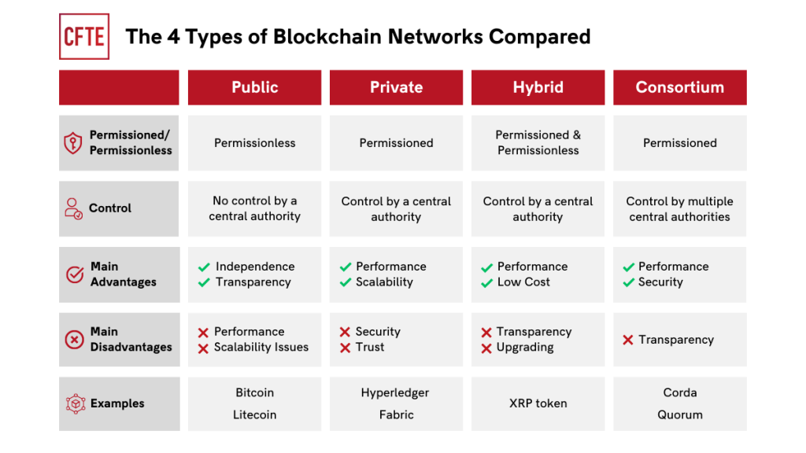
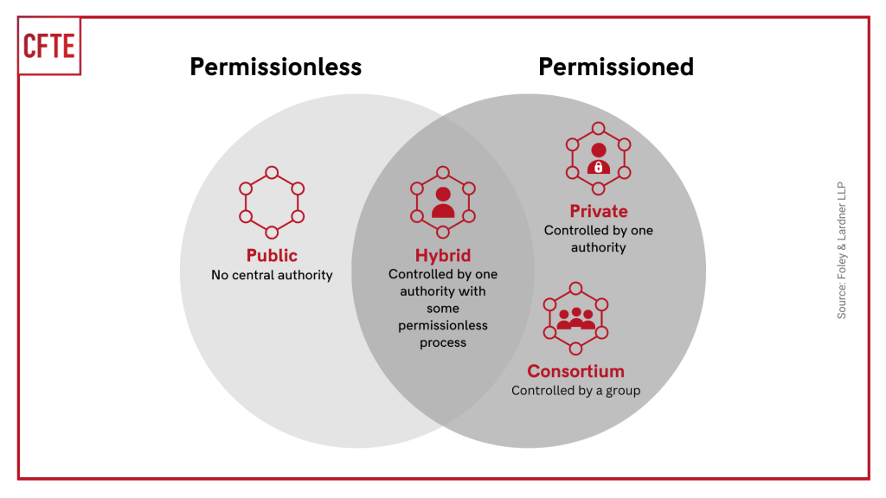

〇 which blockchain to use
Private or the consortium, and they both share the HYPERLEDGER FABRIC

Justification:
- Trace pets’ life through breeder, shelter, owner, vet and some. → each step should be verified and immutable as the ownership info shouldn’t be changing as often
- Healthcare record: only the authorized ones have access

